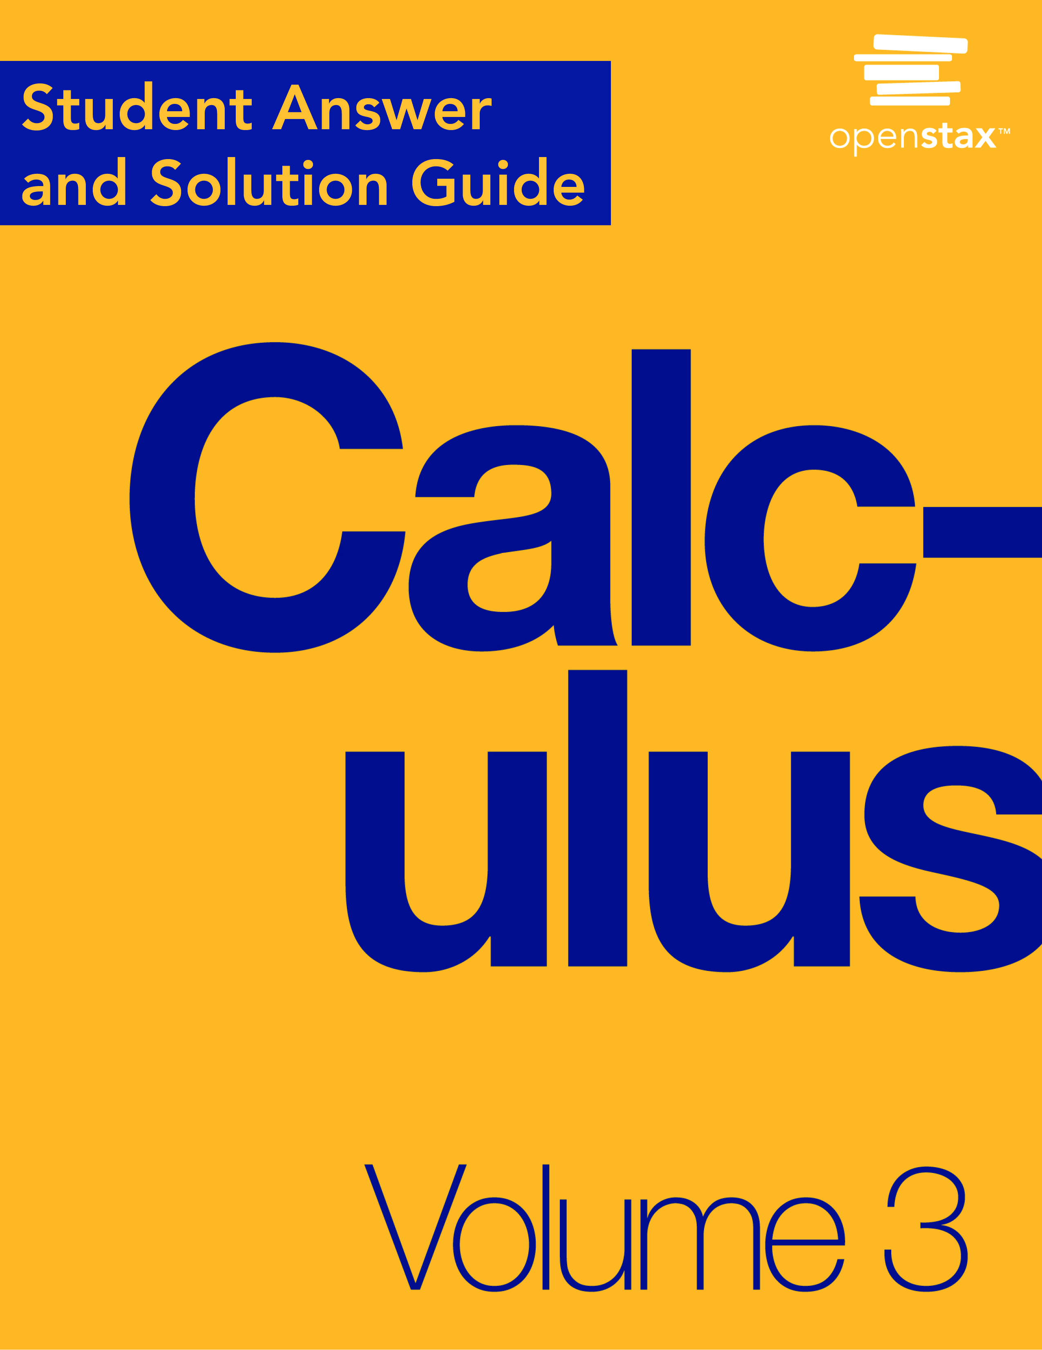

**Chapter 1**

**Parametric Equations and Polar Coordinates**

**1.1 Parametric Equations**

**Section Exercises**

**For the following exercises, sketch the curves below by eliminating the parameter *t*. Give the orientation of the curve.**

1.  

Answer:

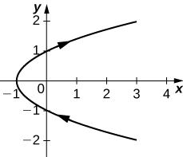

orientation: bottom to top

3. 

Answer:

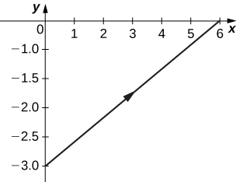

orientation: left to right

**For the following exercises, eliminate the parameter and sketch the graphs.**

5. 

Answer: 

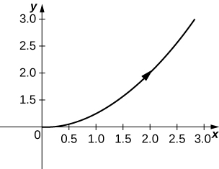

**For the following exercises, use technology (CAS or calculator) to sketch the parametric equations.**

7. **[T]** 

Answer:

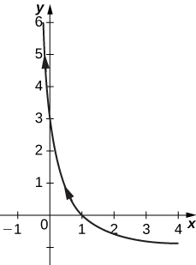

9. **[T]** 

Answer:

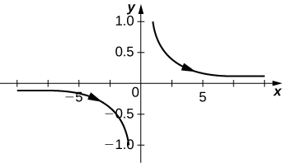

**For the following exercises, sketch the parametric equations by eliminating the parameter. Indicate any asymptotes of the graph.**

11. 

Answer:

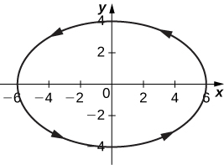

13. 

Answer:

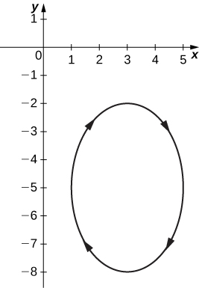

15. 

Answer:

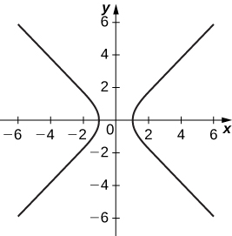

Asymptotes are  and 

17. 

Answer:

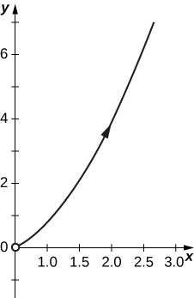

19. 

Answer:

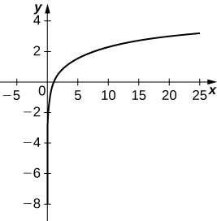

**For the following exercises, convert the parametric equations of a curve into rectangular form. No sketch is necessary. State the domain of the rectangular form.**

21. 

Answer:  domain: .

23. 

Answer:  domain 

25. 

Answer:  domain: all real numbers.

27. 

Answer: ; domain: .

29. 

Answer:  domain: 

31. 

Answer:  domain: 

33. 

Answer:  domain: 

35. where *n* is a natural number

Answer:  domain: 

37. 

Answer:  domain: 

**For the following exercises, the pairs of parametric equations represent lines, parabolas, circles, ellipses, or hyperbolas. Name the type of basic curve that each pair of equations represents.**

39. 

Answer: line

41. 

Answer: parabola

43. 

Answer: circle

45. 

Answer: ellipse

47. 

Answer: hyperbola

49. Show that  represents the equation of a circle.

**For the following exercises, use a graphing utility to graph the curve represented by the parametric equations and identify the curve from its equation.**

51. **[T]** 

Answer: The equations represent a cycloid.

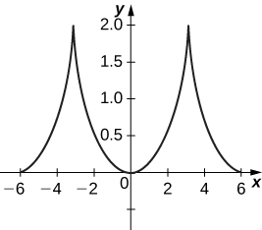

53. **[T]** 

Answer:

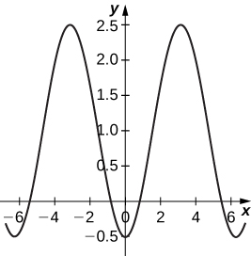

55. The trajectory of a bullet is given by  where   and  When will the bullet hit the ground? How far from the gun will the bullet hit the ground?

Answer: 22,092 meters at approximately 51 seconds.

57. **[T]** Use technology to sketch 

Answer:

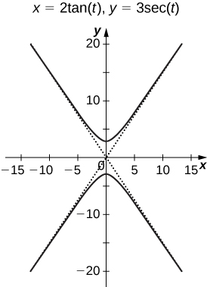

59. **[T]** Use technology to sketch the spiral curve given by  from 

Answer:

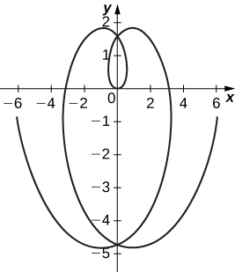

61. **[T]** Sketch the curve given by parametric equations  where 

Answer:

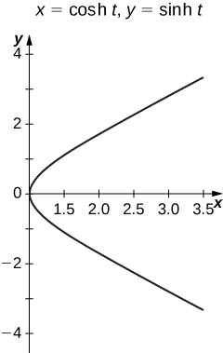

**Student Project**

**The Witch of Agnesi**

1. On the figure, label the following points, lengths, and angle:

1. *C*is the point on the *x*-axis with the same *x*-coordinate as *A*.
2. *x* is the *x*-coordinate of *P*,and *y* is the *y*-coordinate of *P*.
3. *E* is the point 
4. *F* is the point on the line segment *OA* such that the line segment *EF* is perpendicular to the line segment *OA*.
5. *b* is the distance from *O* to *F*.
6. *c* is the distance from *F* to A.
7. *d* is the distance from *O* to *B*.
8.  is the measure of angle 

Answer:

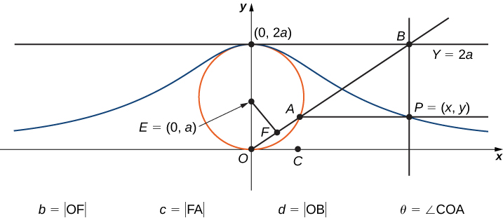

**The goal of this project is to parameterize the witch using  as a parameter. To do this, write equations for *x* and *y* in terms of only **

3. Note that  Show that  When you do this, you will have parameterized the *x*-coordinate of the curve with respect to  If you can get a similar equation for *y*, you will have parameterized the curve.

Answer: The equation  follows from the definition of cosine in the right triangle formed by By 2), we have that



5. Show that 

Answer: Note that the triangle with vertices is a triangle inscribed in a circle where one of the sides is a diameter of the circle. By Thales’ Theorem, this triangle is a right triangle with hypotenuse the side from . Using the answer from 4., the length of  is  But  is also . Therefore



7. Show that  You have now parameterized the *y*-coordinate of the curve with respect to 

Answer: Note that



Using the answer from 6., we have that 

9. Use your parameterization to show that the given witch curve is the graph of the function 

Answer: If  then



**Student Project**

**Travels with My Ant: The Curtate and Prolate Cycloids**

1. What is the position of the center of the wheel after the tire has rotated through an angle of *t*?

Answer: 

3. On the basis of your answers to parts 1 and 2, what are the parametric equations representing the curtate cycloid?

Answer: 

5. What do you notice about your answer to part 3 and your answer to part 4?

Answer: They are the same.

This file is copyright 2016, Rice University. All Rights Reserved.